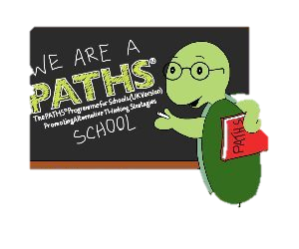

Make a new friend today. Offer to help someone or sit next to someone you don’t know very well.

You may create a great new friendship.

APRIL
PATHS
Quote of the Month

